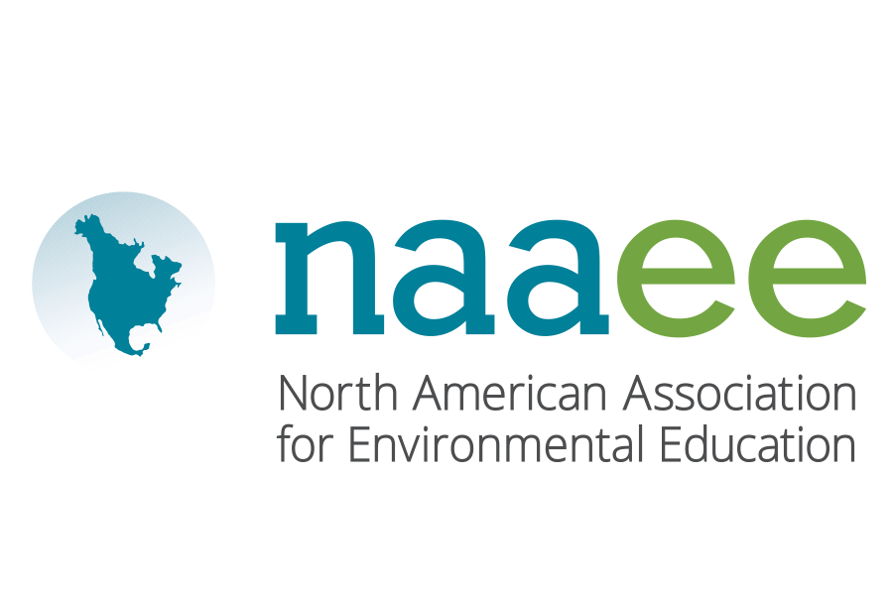

# North American Association for Environmental Education (NAAEE)

**POSITION DESCRIPTION**

**POSITION TITLE**: Natural Start Alliance Conference and Communications Coordinator

**REPORTS TO:** Director, Natural Start Alliance

**LOCATION:** Remote or Based in Washington, DC

**FLSA**: Exempt

BASIC FUNCTIONS:

The Conference and Communications Coordinator helps oversee the Natural Start Alliance annual conference, including the program, venue, registration, sponsors, logistics, communications, volunteers, and other aspects of the conference. The Coordinator also oversees content in all Natural Start communications, including the website, social media, newsletters, and promotional materials. In addition, the Specialist works with the Director and other staff to advise on strategy for Natural Start, provide support to Natural Start members and other audiences, and represent the Natural Start Alliance in a variety of forums.

This is a full-time position.

MAJOR RESPONSIBILITIES:

1. Assists with the annual Natural Start Alliance Conference (45%)
   * Works in collaboration with Natural Start Director and contractors to secure conference venue
   * Assists with the development of the conference program, including the selection of conference sessions
   * Coordinates all conference-related communications, including monthly conference calls, conference promotion, and communications with presenters, exhibitors, and participants
   * Helps secure conference sponsors and serves as their primary point of contact
   * Oversees A/V, catering, signage, seating arrangements, and other day-of-event needs, and works with NAAEE and the Natural Start staff and consultants to make sure all deadlines are met
   * Serves as main point of contact for conference venue representatives, partner organizations, consultants, presenters, and participants
   * Manages conference volunteers in collaboration with local partner organizations
   * Plans and oversees the logistics during the event, working with volunteers, local coordinator, and other staff and consultants
   * Assists with the coordination of conference field trips to local early learning programs and sites
   * Transitions conference activities to virtual formats as appropriate
2. Coordinates the Natural Start Alliance Website and Other Communications (40%)
   * In collaboration with other NAAEE staff, establishes an editorial calendar for the various Natural Start Alliance communication channels
   * Tracks Google Analytics and other measures of engagement with Natural Start content
   * Updates and maintains the Natural Start website, including soliciting, editing, and publishing content that engages members and priority audiences
   * Writes engaging social media posts, and coordinates topics/timing with NAAEE Communications staff and eePRO Discussion Group Moderators
   * Writes, publishes, and tracks engagement with the monthly Natural Start Alliance Newsletter
   * Responds to public and media inquiries
3. Supports the Overall Strategy and Leadership of the Alliance (10%)
   * Participates in leadership meetings, team meetings, and other activities to help guide project goals and strategies
   * Assists with the design and development of reports, press releases, articles, and other publications designed to advocate for nature-based education
   * Maintains relationships with local and regional organizations, individual members, leaders, colleagues, and other stakeholders to help strengthen the Alliance’s professional networks
4. Assists with Special Projects, Outreach, and the NAAEE Conference, as Needed (5%)

* Represent NAAEE at major conferences, events, and meetings, and take part in all creative planning and staff retreats to strengthen the organization, build teamwork, and promote a culture of equity and inclusion
* Assist with special projects, as needed, including supporting other team members and partners
* Assist with the NAAEE annual conference, as needed

WORKING RELATIONSHIPS:

* Internal: Maintains regular contact with NAAEE staff to compile and disseminate information as requested. Participates in all staff calls, retreats, and internal working groups as needed.
* External: Maintains regular contact with external partners and colleagues related to all aspects of the position.

TRAVEL REQUIREMENTS:

The position requires occasional domestic travel.

POSITION REQUIREMENTS AND SPECIFICATIONS:

* Education: Bachelor’s degree or equivalent experience required
* Experience: At least 2–4 years of experience with communication, event planning, and/or membership engagement in early childhood education, environmental education, or related fields. Experience working with a network, alliance, or membership-based organization a plus.
* Skills and abilities: Excellent organizational skills and the ability to work on multiple projects simultaneously. Excellent communication skills, including writing, editing, design, and presentation skills. Excellent interpersonal skills, including ability to work efficiently, with flexibility, creativity, and good humor. Demonstrated ability to build and maintain relationships with a wide variety of individuals and an interest in striving for excellence. Ability and willingness to work evenings and weekends as needed to support the Natural Start Alliance Annual Conference and other special events. Position requires an individual who is culturally competent and can work with individuals representing a diversity of backgrounds and perspectives.

ABOUT NAAEE

For more than five decades, the North American Association for Environmental Education has worked to strengthen and expand the field of environmental education, with a growing network of support including:

* More than 20,000 members and supporters, including members of our Affiliate Network
* 54 state and provincial Affiliate organizations
* More than 30 countries around the world

NAAEE’s mission is to advance environmental literacy and civic engagement using the power of education to create a more equitable and sustainable future. We support a collaborative, team-oriented, dynamic, and enjoyable work environment. We believe that happy and fulfilled employees who are trusted to do their best will create a stronger, highly productive, and effective team contributing to the greater success of the organization and our mission.